**Maksim Razuvaev’s Website specification**

Goal of the website is to show my skills in website development and introduce myself as specialist.

Website consists of five major pages:

1. Home
2. Resume
3. Interests
4. Reflections
5. Guestbook

Each page has navigation bar on the top:

Screenshot 1



Each page has footer navigation bar:

Screenshot 2

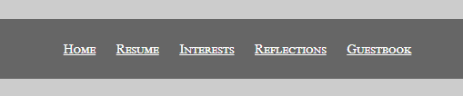

Resume, Interests, Reflection, and Guestbook pages have the art picture on the top under navigation bar:

Screenshot 3

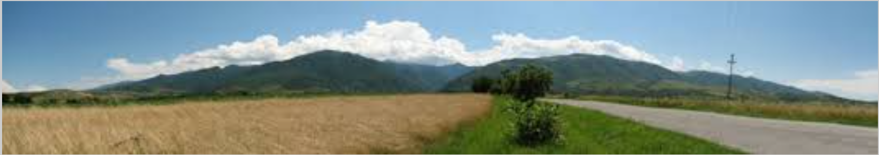

**Home page**

Home page contents my introduction, photo, and two external links to my favorite site.

Screenshot 4

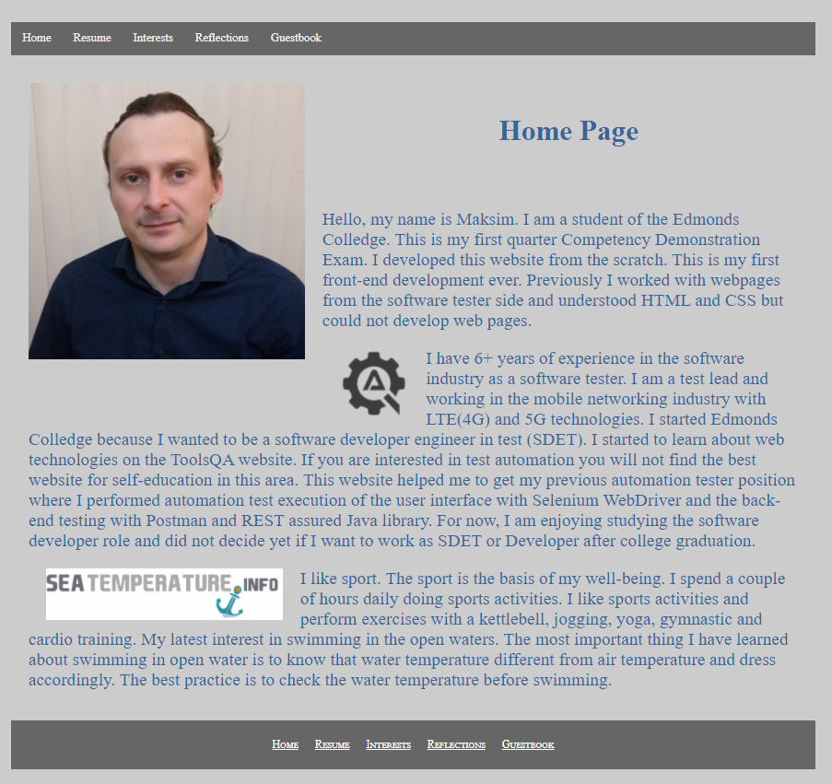

**Resume**

Resume page contents table with job related information and has four major sections:

* Desired Job Description
* Current Skills
* Employment History
* Education

Screenshot 5

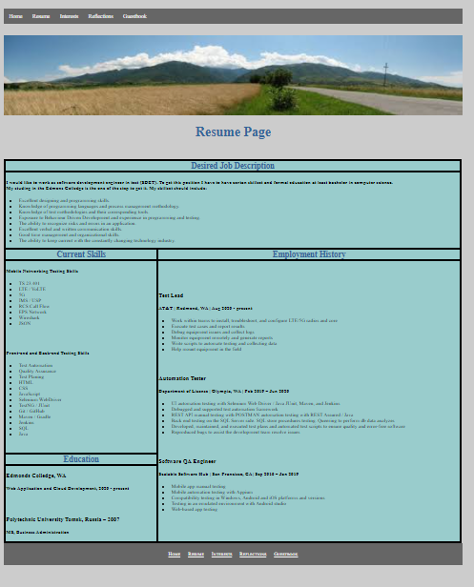

**Interests**

Interests page contents paragraph with unordered list of my interests. Each bullet of the unordered list begins with the link to the external website. Link opens website in the new tab.

Screenshot 6

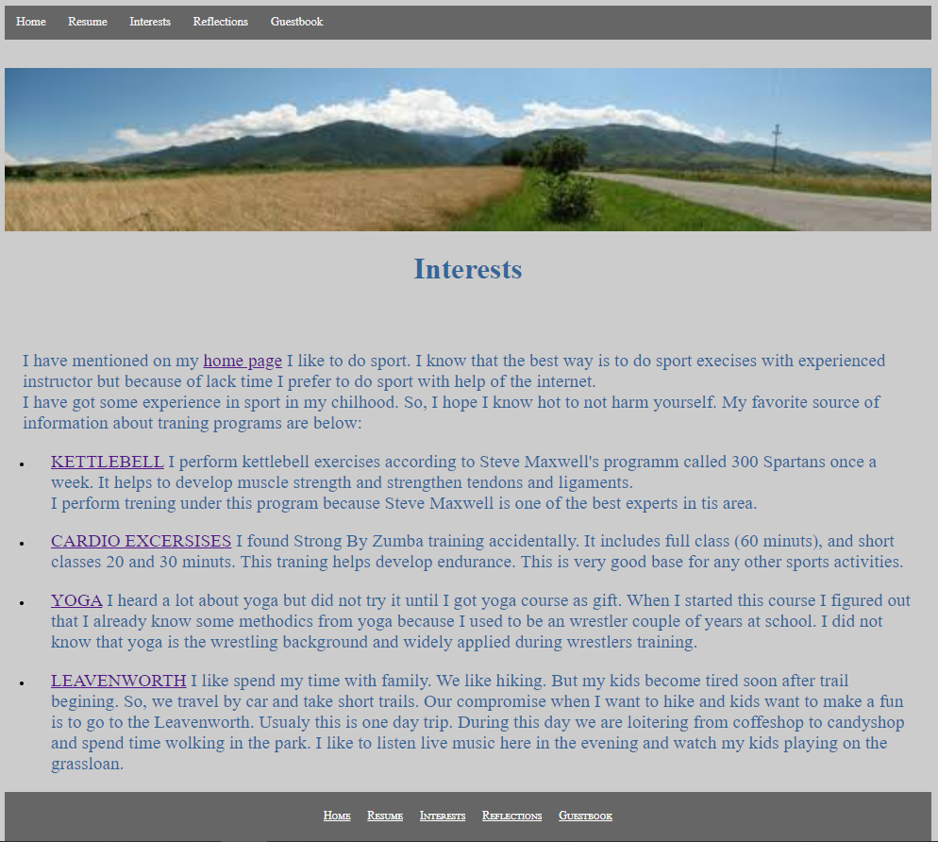

**Reflection**

Reflection page contents my reflection about my CIS 241 experience.

Screenshot 7

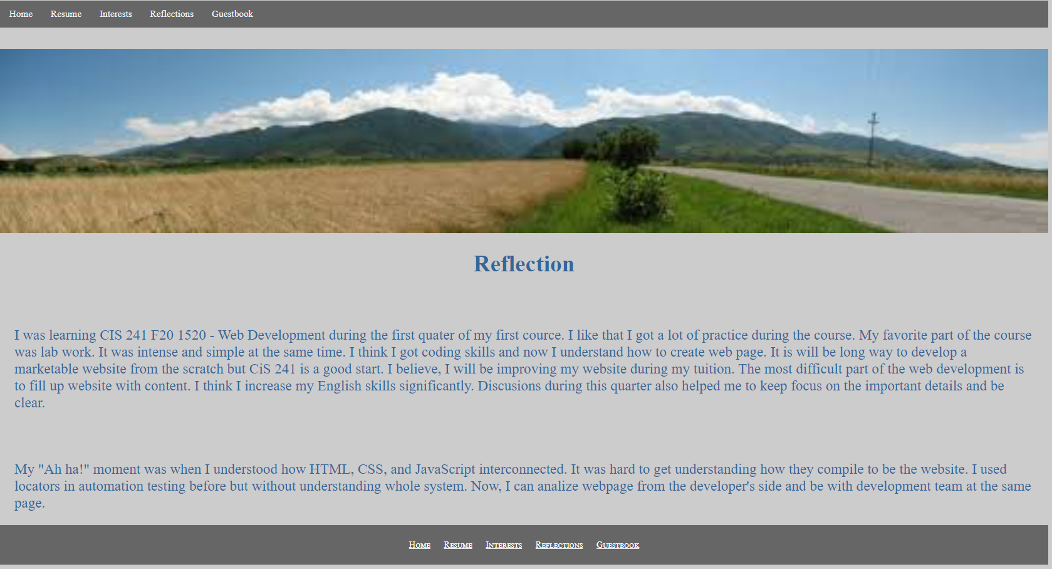

**Guestbook**

Guestbook page contents form with visitor questionnaire.

Screenshot 8

